# **REPORTS Design**

**Daily Collection by Polyclinic**

Ensure that figures add up by viewing a day-by-day breakdown of the total payment amount collected by the polyclinics within a selected date range.

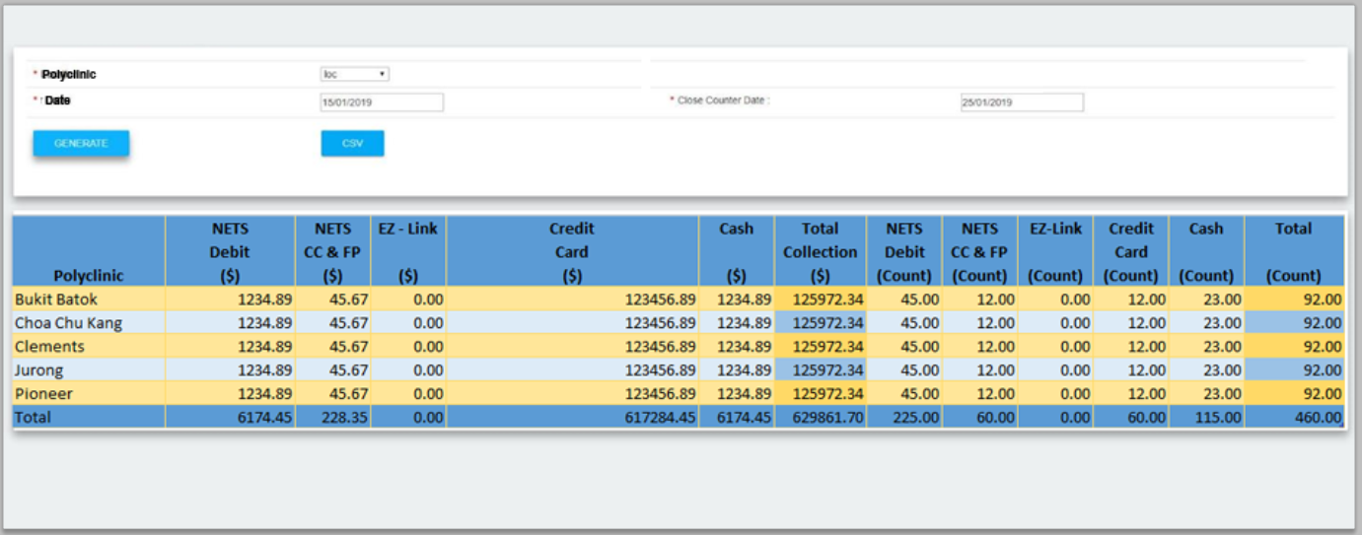

**Input**

| **S/N** | **Field Name** | **Selection Mode** | **Sample Data** | **Default Value** | **Remarks** |
| --- | --- | --- | --- | --- | --- |
| 1 | *Polyclinic*  *[QsoftInstituition]*  *[InstituitionName]* | *Dropdown-single selection* | *ALL, Jurong, Queenstown*  *(vị trí, như tên tỉnh thành)* | *-* | *Location* |
| 2 | *Date From* | *Free entry, Calendar Option* | *DD/MM/YYYY* | *Today’s Date* | *-* |
| *3* | *Date End* | *Free entry, Calendar Option* | *DD/MM/YYYY* | *Today’s Date* | *-* |

*Note: Exportable to Excel*

**Output**

***\*All output to be filtered according to input’s polyclinic and date range***

***Table[SPKPaymentMaster][PolyCode] links to table [QsoftInstituition][InstituitionCodeName]***

***Table[SPKPaymentMaster[ReceivedTime] is used as the criteria to check if it falls between the input date range.***

| **S/N** | **Field Name** | **Sample Data** | **Remarks** |
| --- | --- | --- | --- |
| 1 | *Input Criteria* | As per input | Based on above input fields (show in exported excel) |
| 2 | *Extracted Date/ Time* | 9/11/2019 11:10:00 AM | Based on report generation date/time (show in exported excel) |
|  |  |  |  |
| 1 | Date | 19/10/2019 | Date of collection |
| 2 | *Polyclinic*  *[QsoftInstituition]*  *[InstituitionName]*  *This should be according to the above input.* | Pioneer Polyclinic | Location (Consolidation of payment data of all domains for 1 Polyclinic.) |
| 3 | *Zero Payment* | $0.00 | Amount collected for the payment mode |
| 4 | *NETS Debit ($)*  *[SPKPaymentInfo]*  *[AmountPaid]*  *Take the total amount, where PaymentCategoryId = 2, PaymentModeId =3* | $10.00 | Amount collected for the payment mode |
| 5 | *NETS CC & FP ($)*  *[SPKPaymentInfo]*  *[AmountPaid]*  *Take the total amount, where PaymentCategoryId = 2, PaymentModeId =4 & 12* | $10.00 | Amount collected for the payment mode |
| 6 | *NETS CDA*  *[SPKPaymentInfo]*  *[AmountPaid]*  *Take the total amount, where PaymentCategoryId = 2, PaymentModeId =13* | $0.00 | Amount collected for the payment mode |
| 7 | *~~EZ - Link ($)~~* | $10.00 | Amount collected for the payment mode |
| 8 | *Credit Card ($)*  *[SPKPaymentInfo]*  *[AmountPaid]*  *Take the total amount, where PaymentCategoryId = 1* | $10.00 | Amount collected for the payment mode |
| 9 | *Cash ($)*  *[SPKPaymentInfo]*  *[AmountPaid]*  *Take the total amount, where PaymentCategoryId = 3* | $10.00 | Net Amount collected for the payment mode |
| 10 | *Total Collection ($)*  *[Sum of column 3-9]* | $50.00 | Total Amount collected |
| 11 | *Zero Payment* | 5 | No of transaction for the payment mode |
| 12 | *NETS Debit (Count)*  *[SPKPaymentMaster]* | 5 | No of transaction for the payment mode |
| 13 | *NETS CC & FP(Count)*  *[SPKPaymentMaster]* | 5 | No of transaction for the payment mode |
| 14 | *NETS CDA(Count)* | 5 | No of transaction for the payment mode |
| 15 | *~~EZ-Link (Count)~~* | 5 | No of transaction for the payment mode |
| 16 | *Credit Card (Count)*  *[SPKPaymentMaster]* | 5 | No of transaction for the payment mode |
| 17 | *Cash (Count)*  *[SPKPaymentMaster]* | 5 | No of transaction for the payment mode |
| 18 | *Total (Count)*  *[Sum of column 11-17]* | 30 | Total No of transaction |

**Sorting Order**

| **S/N** | **Field Name** | **Remarks** |
| --- | --- | --- |
| 1 | Date | Earliest above |
| 2 | Polyclinic | Alphabetical order |

**Daily Collection by Kiosks**

Ensure that figures add up by viewing a daily breakdown of the total payment amount collected by kiosks at each location within a selected date range.

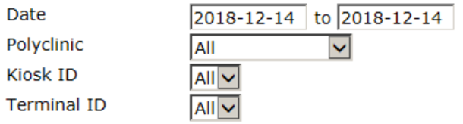

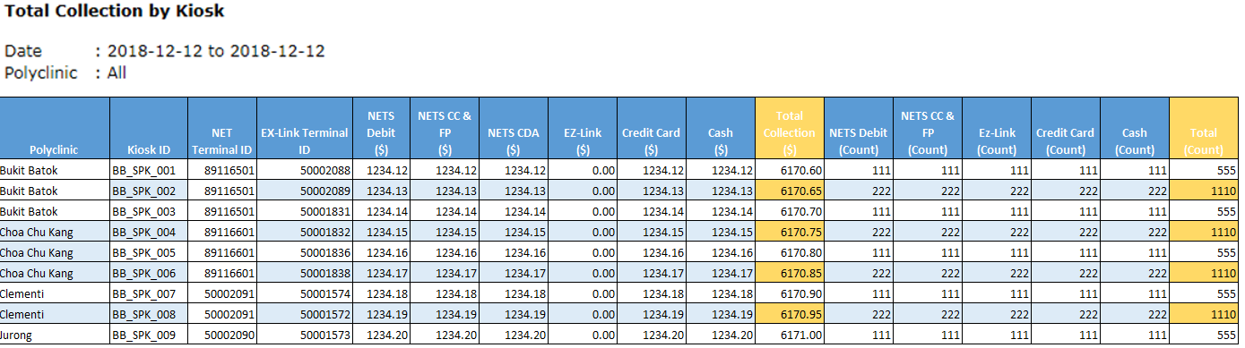

**Input**

| **S/N** | **Field Name** | **Selection Mode** | **Sample Data** | **Default Value** | **Remarks** |
| --- | --- | --- | --- | --- | --- |
| 1 | *Date From* | *Free entry, Calendar Option* | *DD/MM/YYYY* | *Today’s Date* | *-* |
| 2 | *Date End* | *Free entry, Calendar Option* | *DD/MM/YYYY* | *Today’s Date* | *-* |
| *3* | *Polyclinic*  *[QsoftInstituition]*  *[InstituitionName]* | *Dropdown-single selection* | *ALL, Jurong, Queenstown* | *-* | *Location* |
| *4* | Kiosk ID  *[QsoftTerminal]*  *[TerminalName]* | *Dropdown-single selection* | *ALL, BBK_KSK_001* | *ALL* | *-* |
| *5* | *Terminal ID*  [QsoftTerminal]  [NetTerminalName] | *Dropdown-single selection* | *ALL, 88676501-NETS* | *ALL* | *This is the specific device ID of a particular kiosk for the transaction.* |

**Output**

**\***Do filter the output according to all the input criteria: Polyclinic, date range, kiosk & terminal ID

*Only show output that have a [PaymentEndTime] in table [SPKPaymentMaster]

| **S/N** | **Field Name** | **Sample Data** | **Remarks** |
| --- | --- | --- | --- |
| 1 | Date  *[SPKPaymentMaster]*  *[requestTime]*  *Output only the date* | 19/10/2019 | Date of collection |
| 2 | *Polyclinic*  *[QsoftInstituition]*  *[InstituitonName]* | Pioneer | Location (Consolidation of payment data of all domains for 1 Polyclinic.) |
| 3 | *Kiosk Id*  *[QsoftTerminal]*  *[TerminalName]*  *Linked by [SPKPayment][TerminalId]* | PIO_KSK_001 | Internal Kiosk ID |
| 4 | *NETS Terminal ID*  *[SPKPaymentMaster]*  *[NetTerminalId]* | 89116501 | *This is the specific device ID of a particular kiosk for the transaction.* |
| 5 | *~~EZ-Link Terminal ID~~* | 50002088 | *This is the specific device ID of a particular kiosk for the transaction.* |
| 6 | *NETS Debit ($)*  *[SPKPaymentInfo]*  *[AmountPaid]*  *Total amount paid, where PaymentCategoryId = 2, PaymentModeId =3* | $10.00 | Amount collected for the payment mode |
| 7 | *NETS CC & FP ($)*  *[SPKPaymentInfo]*  *[AmountPaid]*  *Take the total amount, where PaymentCategoryId = 2, PaymentModeId =4 & 12* | $10.00 | Amount collected for the payment mode |
| 8 | *NETS CDA* | $0.00 | Amount collected for the payment mode |
| 9 | *~~EZ - Link ($)~~* | $10.00 | Amount collected for the payment mode |
| 10 | *Credit Card ($)*  *[SPKPaymentInfo]*  *[AmountPaid]*  *Take the total amount, where PaymentCategoryId = 1* | $10.00 | Amount collected for the payment mode |
| 11 | *Cash ($)*  *[SPKPaymentInfo]*  *[AmountPaid]*  *Take the total amount, where PaymentCategoryId = 3* | $10.00 | Net Amount collected for the payment mode |
| 12 | *Total Collection ($)*  *[sum of column 6 – 11]* | $50.00 | Total Amount collected |
| 13 | *NETS Debit (Count)*  *[SPKPaymentMaster]* | 5 | No of transaction for the payment mode |
| 14 | *NETS CC & FP(Count)*  *[SPKPaymentMaster]* | 5 | No of transaction for the payment mode |
| 15 | *NETS CDA(Count)* | 5 | No of transaction for the payment mode |
| *16* | *~~EZ-Link (Count)~~* | 5 | No of transaction for the payment mode |
| *17* | *Credit Card (Count)*  *[SPKPaymentMaster]* | 5 | No of transaction for the payment mode |
| *18* | *Cash (Count)*  *[SPKPaymentMaster]* | 5 | No of transaction for the payment mode |
| *19* | *Total (Count)*  *[sum of column 13 – 18]* | 30 | Total No of transaction |

*Note: Exportable to Excel*

**Sorting Order**

| **S/N** | **Field Name** | **Remarks** |
| --- | --- | --- |
| 1 | Date | Earliest above |
| 2 | Polyclinic | Alphabetical order |
| 3 | Kiosk ID | Alphabetical order |

**Transaction Error Report**

View individual error transactions made through kiosks, including details like amount, payment mode, device ID, patient info, bill info, error time for a selected date range.

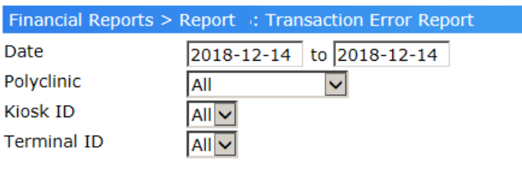

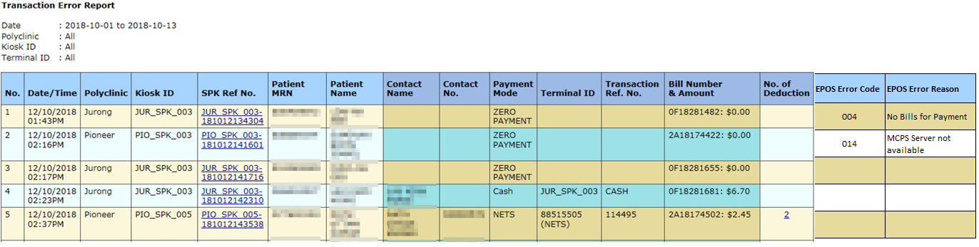

**Input**

| **S/N** | **Field Name** | **Selection Mode** | **Sample Data** | **Default Value** | **Remarks** |
| --- | --- | --- | --- | --- | --- |
| 1 | *Date From* | *Free entry, Calendar Option* | *DD/MM/YYYY* | *Today’s Date* | *-* |
| 2 | *Date End* | *Free entry, Calendar Option* | *DD/MM/YYYY* | *Today’s Date* | *-* |
| *3* | *Polyclinic*  *[QsoftInstituition]*  *[InstituitionName]*  *Linked by [SPKPaymentMaster]*  *[PolyCode]* | *Dropdown-single selection* | *ALL, Bukit Batok* | *-* | Location |
| *4* | Kiosk ID  [QsoftTerminal]  [TerminalName] | *Dropdown-single selection* | *ALL, BBK_KSK_001* | *ALL* | *-* |
| *5* | *Terminal ID*  *[QsoftTerminal]*  *[NetTerminalName]* | *Dropdown-single selection* | *ALL, 88676501-NETS* | *ALL* | *This is the specific device ID of a particular kiosk for the transaction.* |
| *6* | Patient MRN  *[SPKPaymentMaster]*  *[PatientMRN]* | *Free entry* | *S1234567J* |  | *If no input, then results return all patients.* |

**Output**

*Do note to filter outputs according to input criteria: Polyclinic, Kiosk & terminal ID, Patient MRN, data range. **Output transaction error only – [SPKPaymentMaster][EPOSResponseStatus] is not 000**

| **S/N** | **Field Name** | **Sample Data** | **Remarks** |
| --- | --- | --- | --- |
| 1 | *Input Criteria*  [To display the above input criteria when export to excel] | As per input | Based on above input fields (show in exported excel) |
| 2 | *Extracted Date/ Time* | 9/11/2019 11:10:00 AM | Based on report generation date/time (show in exported excel) |
|  |  |  |  |
| 1 | *Date/Time*  *[SPKPaymentMaster]*  *[requestTime]* | 19/10/2019 11:10:00 AM | Transaction Date and Time |
| 2 | *Polyclinic*  *[QsoftInstituition]*  *[InstituitionName]* | Pioneer | Location (Consolidation of payment data of all domains for 1 Polyclinic.) |
| 3 | *Kiosk Id*  *[QsoftTerminal]*  *[TerminalName]*  *Linked by [SPKPaymentMaster]*  *[TerminalId]* | PIO_KSK_001 | Internal Kiosk ID |
| 4 | *SPK Ref No.*  *[SPKPaymentMaster]*  *[KioskId] + [PaymentMasterId]* | PIO_KSK_001-19102019123456 | Internal Transaction Reference number |
| 5 | *Patient MRN*  *[SPKPaymentMaster]*  *[PatientMRN]* | S1234567G | - |
| 6 | *Patient name*  *[SPKPaymentMaster]*  *[PatientName]* | Tan Ah Bee | - |
| 7 | *~~Contact Name~~* | Tan Lee Lee | If contacts page prompted on kiosk and entered |
| 8 | *~~Contact No.~~* | 91234567 | If contacts page prompted on kiosk and entered |
| 9 | *Payment Mode*  *[SPKPaymentMode]*  *[Description]* | NETS | - |
| 10 | *Terminal ID*  *[SPKPaymentMaster]*  *[[NetTerminalId]* | *88676501-NETS* | *This is the specific device ID within the kiosk for the transaction.* |
| 11 | *Transaction Ref. No.*  *[SPKPaymentMaster]*  *[NetTransactionRefNo]* | 220632 | External Transaction Reference number |
| 12 | *Bill Number & Amount*  *[SPKPaymentInfo]*  *[BillNumber]*  *[AmountPaid]*  *Linked by [SPKPaymentMaster]*  *[PaymentInfoId]* | 2A18123231: $40.00 | Note there could be multiple bills paid in one transaction |
| *13* | *No. of Deduction* | 2 | Displays 2 if there is a double deduction for a transaction |
| *14* | *~~EPOS~~ Error Code*  *[SPKPaymentMaster]*  *[EPOSResponseStatus]* | 014,  004 | Displays the Error Code from EPOS if there is any error. Refer to the Section 4.2 Error Codes from the ESB-EPOS Interface Specs. |
| *15* | *~~EPOS~~ Error Reason*  *[RetrieveErrorCode]*  *[Logic]*  *Linked by [SPKPaymentMaster]*  *[EPOSResponseStatus]*  *->*  *[RetrieveErrorCode]*  *[Code]* | MCPS Server not available,  No Bills for Payment | Display the Error Reason from EPOS if there is any error. Refer to the Section 4.2 Error Codes from the ESB-EPOS Interface Specs. |

*Note: Exportable to Excel*

**Sorting Order**

| **S/N** | **Field Name** | **Remarks** |
| --- | --- | --- |
| 1 | *Date/Time* | *Earliest above* |
| 2 | *Polyclinic* | *Alphabetical* |
| 3 | *Kiosk id* | *Alphabetical* |

**Patient Transaction Report**

View payment transaction details including statistics for NRIC scan time, receipt print time and transaction time, with transaction time filter.



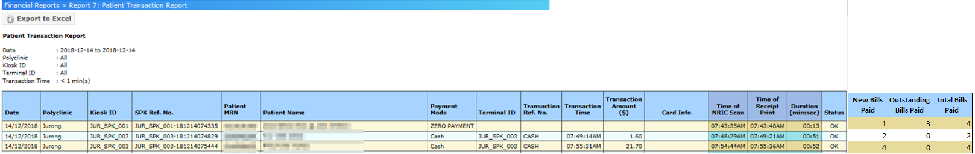

**Input**

| **S/N** | **Field Name** | **Selection Mode** | **Sample Data** | **Default Value** | **Remarks** |
| --- | --- | --- | --- | --- | --- |
| 1 | *Date From* | *Free entry, Calendar Option* | *DD/MM/YYYY* | *Today’s Date* | *-* |
| 2 | *Date End* | *Free entry, Calendar Option* | *DD/MM/YYYY* | *Today’s Date* | *-* |
| *3* | *Polyclinic*  *[QsoftInstituition]*  *[InstituitionName]* | *Dropdown-single selection* | *ALL, Bukit Batok* | *-* | *Location* |
| *4* | Kiosk ID  [QsoftTerminal]  [TerminalName] | *Dropdown-single selection* | *ALL, BBK_KSK_001* | *ALL* | *-* |
| *5* | *Terminal ID*  [QsoftTerminal]  [NetTerminalName] | *Dropdown-single selection* | *ALL, 88676501-NETS* | *ALL* | *This is the specific device ID of a particular kiosk for the transaction.* |
| *6* | Patient MRN  [SPKPaymentMaster]  [PatientMRN]  If no input, display all transactions made according to the above inputs | *Free entry* | *S1234567J* |  | *If no input, then results return all patients.* |

**Output**

**\***Filter according to input criteria. 1 row of output should display a unique payment, which is recorded in table [SPKPaymentMaster]

| **S/N** | **Field Name** | **Sample Data** | **Remarks** |
| --- | --- | --- | --- |
| 1 | *Input Criteria*  [To display the above input criteria when export to excel] | As per input | Based on above input fields (show in exported excel) |
| 2 | *Extracted Date/ Time* | 9/11/2019 11:10:00 AM | Based on report generation date/time (show in exported excel) |
|  |  |  |  |
| 1 | *Date*  *[SPKPaymentMaster]*  *[requestTime]* | 19/10/2019 | Date of transaction |
| 2 | *Polyclinic*  *[QsoftInstituition]*  *[InstituitionName]* | Pioneer Polyclinic | Location (Consolidation of payment data of all domains for 1 Polyclinic.) |
| 3 | *Kiosk Id*  *[QsoftTerminal]*  *[TerminalName]* | PIO_KSK_001 | Internal Kiosk ID |
| 4 | *SPK Ref No.*  *[SPKPaymentMaster]*  *[KioskId] + [PaymentMasterId]* | PIO_KSK_001-19102019123456 | Internal Transaction number |
| 5 | *Patient MRN*  *[SPKPaymentMaster]*  *[PatientMRN]* | S1234567K | - |
| 6 | *Patient name*  *[SPKPaymentMaster]*  *[PatienName]* | Tan Ah Kow | - |
| 7 | *Time of NRIC Scan*  *[SPKPaymentMaster]*  *[RequestTime]* | 11:05:00 AM | Time NRIC is scanned |
| 8 | *Payment Mode*  *[SPKPaymentMode]*  *[Description]* | NETS | - |
| 9 | *Terminal ID*  *[QsoftTerminal]*  *[NetTerminalName]* | *88676501-NETS* | - |
| 10 | *Transaction Ref No.*  *[SPKPaymentMaster]*  *[NetTransactionRefNo]* | 220632 | External Transaction Reference number |
| 11 | *Transaction Time*  *[SPKPaymentMaster]*  *[SPKPaymentEndTime]* | 11:10:00 AM | Completion time of payment transaction. (i.e. Successful deduction of cashless payment or successful cash payment) |
| 12 | *Transaction Amount*  *[SPKPaymentMaster]*  *[AmountPaid]* | $50.00 | Net amount collected for the payment mode |
| 13 | *Card Info.*  *[SPKCardInfo]*  *[Last4Digits]*  *Linked by [PaymentInfoId]* | MASTERCARD  XXXXXXXXXXX2417 | Note masking required |
| *14* | *Time of Receipt Print*  *[SPKPaymentMaster]*  *[ReceiptPrintOutEndTime]* | 11:10:50 AM | Time Bill Receipt is printed |
| *15* | *Duration (min:sec)*  *[Column 14 – Column 7]* | 05:50 | Time of Receipt Print – Time of NRIC Scan |
| *16* | *Status* | OK | Can be ‘-‘ if no payment is made. |
| *17* | *New Bills Paid*  *[EPOSBillsDetails]*  *Count the bills that BillTypeId = 1*  *Linked by [SPKPaymentMaster]*  *[PaymentMasterId]* | 1 | No. of new bills paid in this transaction |
| *18* | *Outstanding Bills Paid*  *[EPOSBillsDetails]*  *Count the bills that BillTypeId = 2*  *Linked by [SPKPaymentMaster]*  *[PaymentMasterId]* | 3 | No. of outstanding bills paid in this transaction |
| *19* | *Total Bills Paid*  *[sum of column 17-18]* | 4 | Total no. of bills paid in this transaction |

*Note: Exportable to Excel*

**Sorting Order**

| **S/N** | **Field Name** | **Remarks** |
| --- | --- | --- |
| 1 | *Date/Time* | *Earliest above* |
| 2 | *Polyclinic* | *Alphabetical* |
| 3 | *Kiosk id* | *Alphabetical* |

* + 1. **SPK – Audit Trail**

**Extract Visit**

Discloses details of payment transaction, each payment stage’s status, date range for a particular patient.

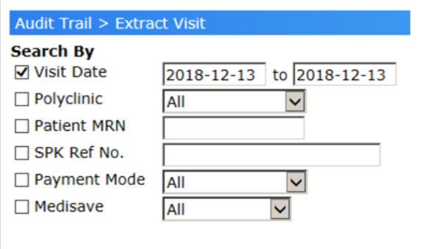

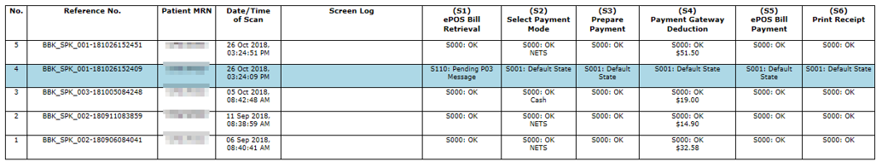

**Input**

| **S/N** | **Field Name** | **Selection Mode** | **Sample Data** | **Default Value** | **Remarks** |
| --- | --- | --- | --- | --- | --- |
| 1 | *Date From* | *Free entry, Calendar Option* | *DD/MM/YYYY* | *Today’s Date* | *-* |
| 2 | *Date End* | *Free entry, Calendar Option* | *DD/MM/YYYY* | *Today’s Date* | *-* |
| *3* | *Polyclinic*  *[QsoftInstituition]*  *[InstituitionName]* | *Dropdown-single selection* | *ALL, Bukit Batok* | *-* | *Location* |
| *4* | *Kiosk ID*  *[QsoftTerminal]*  *[TerminalName]* | *Dropdown-single selection* | *ALL, BBK_KSK_001* | *ALL* | *List all relevant Kiosk IDs based on the Polyclinic selected.* |
| *5* | *Patient MRN* | *Free entry* | *S1234567J* |  | *-* |
| *6* | *SPK. Ref No* | *Free entry* | PIO_KSK_001-19102019123456 |  | *-* |
| *7* | *Payment Mode*  *[SPKPaymentMode]*  *[Description]* | *Dropdown-single selection* | *NETS* | *ALL* | *-* |
| *8* | *Medisave*  *[All, Yes, No]* | *Dropdown-single selection* | *ALL, Yes, No* | *ALL* | *-* |

**\***[SPKPaymentMaster][MedisaveClaimableIndicator]: 0 is Yes, 1 is No. This is for input column 8.

**Output**

| **S/N** | **Field Name** | **Sample Data** | **Remarks** |
| --- | --- | --- | --- |
| 1 | *Input Criteria*  [Show input criteria when exported to excel] | As per input | Based on above input fields (show in exported excel) |
| 2 | *Extracted Date/ Time* | 9/11/2019 11:10:00 AM | Based on report generation date/time (show in exported excel) |
|  |  |  |  |
| 1 | *Reference No*  *[QsoftTerminal]*  *[TerminalName] +*  *[SPKPaymentMaster]*  *[PaymentMasterId]* | PIO_KSK_01-19102019123456 | - |
| 2 | *Patient MRN*  *[SPKPaymentMaster]*  *[PatientMrN]* | S1234567K | - |
| 3 | *Date/time of Scan*  *[SPKPaymentMaster]*  *[RequestTime]* | 19/10/2019 11:10:00 AM |  |
| 4 | *Screen Log* | Med-N  MCPS-N  Appt-Err | This shows the selection by patient on screen if any:  Examples:  If Medication prompt appears and patient chooses N, show “Med-N”.  If future appointment is applicable and patient chooses “Exit”, show “Appt-N”  If there is error in apt interface, show “Appt-Err”. |
| 5 | *(S1) ePOS Bill Retrieval*  *[SPKPaymentMaster]*  *[EPOSResponseStatus]*  *+*  *[RetrieveErrorCode]*  *[Logic]* |  | Bill retrieval status code and outcome |
| 6 | *(S2) Select Payment Mode*  *[SPKPaymentMode]*  *[Description]* |  | Payment mode selected and status. |
| 7 | *(S4) Payment gateway Deduction*  *[SPKPaymentMaster]*  *[GatewayStatus] +*  *[AmountPaid]* |  | Payment gateway payment status and amount paid. |
| 8 | *(S5) ePOS Bill Payment*  *[SPKPaymentMaster]*  *[UpdateStatus]* |  | Payment update to EPOS status. |
| 9 | *(S6) Print Receipt*  *[SPKPaymentMaster]*  *[ReceiptPrintOutStatus]* |  | Receipt print status. |

*Note: Exportable to Excel*

**Sorting Order**

| **S/N** | **Field Name** | **Remarks** |
| --- | --- | --- |
| 1 | *Reference No.* | *Alphabetical* |

* + 1. **SPK – Cash**

­­­­­­

**Cash Collection & Change Analysis/Change Given Video**

1. Track cash collections by seeing individual cash payments made through kiosks, including details like patient info, device ID, amount received, change due, change given, and deposit collected for a date range for a selected polyclinic.
2. Track and ensure payments collected add up by viewing individual cash payments made through kiosks, including details like transaction timestamp, device ID, amount received, and change given (breakdown by compartment) for a date range for selected polyclinic.
3. URL to view videos of individual cash payments made through kiosk to verify details when discrepancies arise to be included for each payment.

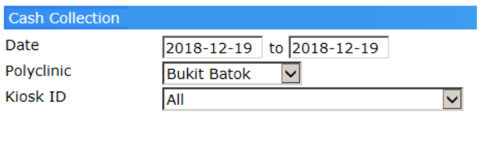

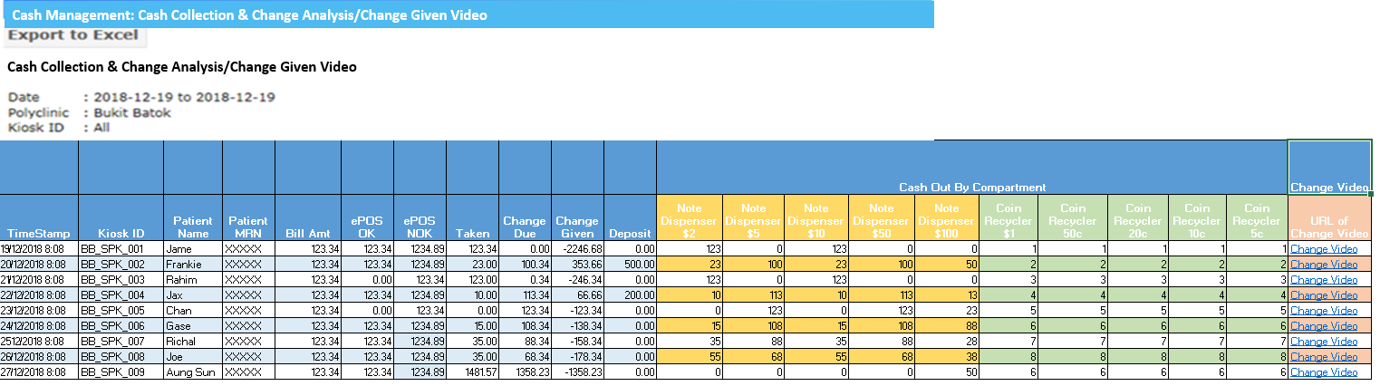

**Input**

| **S/N** | **Field Name** | **Selection Mode** | **Sample Data** | **Default Value** | **Remarks** |
| --- | --- | --- | --- | --- | --- |
| 1 | *Date From* | *Free entry, Calendar Option* | *DD/MM/YYYY* | *Today’s Date* | *-* |
| 2 | *Date End* | *Free entry, Calendar Option* | *DD/MM/YYYY* | *Today’s Date* | *-* |
| *3* | *Polyclinic*  *[QsoftInstituition]*  *[InstituitionName]* | *Dropdown-single selection* | *ALL, Bukit Batok* |  | *-* |
| *4* | *Kiosk ID*  *[QsoftTerminal]*  *[TerminalName]* | *Dropdown-single selection* | *ALL, BBK_KSK_03* | *ALL* | *List all relevant Kiosk IDs based on the Polyclinic selected.* |

**Output**

| **S/N** | **Field Name** | **Sample Data** | **Remarks** |
| --- | --- | --- | --- |
| 1 | *Input Criteria*  [Show input criteria in export to excel] | As per input | Based on above input fields (show in exported excel) |
| 2 | *Extracted Date/ Time* | 9/11/2019 11:10:00 AM | Based on report generation date/time (show in exported excel) |
|  |  |  |  |
| 1 | *Timestamp* | 9/11/2019 11:10:00 AM | Time completing the insertion of cash |
| 2 | *Polyclinic* | Pioneer Polyclinic | Location |
| 3 | *Kiosk ID* | *BBK_KSK_003* | Internal kiosk ID |
| 4 | *Patient Name* | Tan Ah Bee | - |
| 5 | *Patient MRN* | S1234567K | - |
| 6 | *Bill Amt* | $50.00 | Total amount to be paid (including outstanding bill) |
| 7 | *ePOS OK* | $60.00 | If payment to EPOS is successful, amount submitted to EPOS is shown here. |
|  | *ePOS NOK* |  | If payment to EPOS is unsuccessful, amount submitted to EPOS is shown here. |
| 8 | *Taken* | $60.00 | Cash accepted from patient |
| 9 | *Change Due* | $10.00 | Change due to patient |
| 10 | *Change Given* | $0.00 | Change dispensed for patient |
| 11 | *Deposit* | $10.00 | Amount accepted due to insufficient change to be put as deposit |
|  | Cash In /Cash Out by Compartment | | |
| 12 | *~~Note Dispenser $10~~*  *Note Dispenser $2* | 123 | Quantity dispensed |
| 13 | *Note Dispenser $5* | 0 | Quantity dispensed |
| 14 | *Note Dispenser $10* | 123 | Quantity dispensed |
| 15 | *Note Dispenser $50* | 0 | Quantity dispensed |
| 16 | *Note Dispenser $100* | 0 | Quantity dispensed |
| 17 | *Coin Recycler $1* | 1 | Quantity dispensed |
| 18 | *Coin Recycler 50c* | 1 | Quantity dispensed |
| 19 | *Coin Recycler 20c* | 1 | Quantity dispensed |
| 20 | *Coin Recycler 10c* | 1 | Quantity dispensed |
| 21 | *Coin Recycler 5c* | 1 | Quantity dispensed |
| ~~22~~ | *~~Note Dispenser $10~~*  *~~Note Dispenser $2~~* | ~~123~~ | ~~Quantity dispensed~~ |
| ~~23~~ | *~~Note Dispenser $5~~* | ~~0~~ | ~~Quantity dispensed~~ |
|  | Change Video | | |
| 24 | *URL of Change Video* | Generic URL (Change Video) | 20 |

*Note: Exportable to Excel*

**Sorting Order**

| **S/N** | **Field Name** | **Remarks** |
| --- | --- | --- |
| 1 | *Timestamp* | *Earliest above* |
| 2 | *Polyclinic* | *Alphabetical order* |
| 3 | *Kiosk Id* | *Alphabetical order* |

**Cash Event Summary**

Manage accurate daily closing reports through viewing the state of the compartments before and after each activity involving cash compartments (e.g. top ups, empty change).

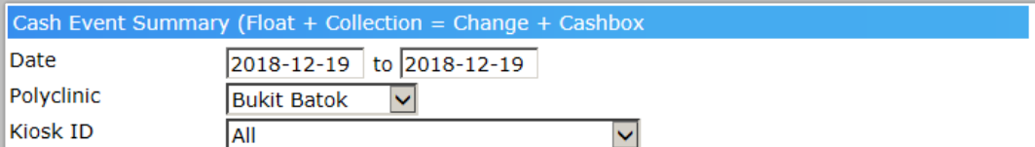

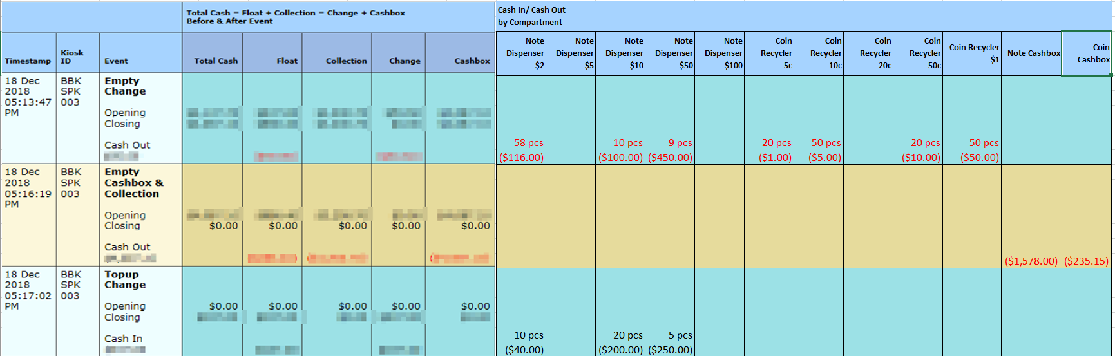

**Input**

| **S/N** | **Field Name** | **Selection Mode** | **Sample Data** | **Default Value** | **Remarks** |
| --- | --- | --- | --- | --- | --- |
| 1 | *Date From* | *Free entry, Calendar Option* | *DD/MM/YYYY* | *Today’s Date* | *-* |
| 2 | *Date End* | *Free entry, Calendar Option* | *DD/MM/YYYY* | *Today’s Date* | *-* |
| *3* | *Polyclinic* | *Dropdown-single selection* | *ALL, Bukit Batok* |  | *-* |
| *4* | *Kiosk ID* | *Dropdown-single selection* | *ALL, BBK_SPK_003* | *ALL* | *List all relevant Kiosk IDs based on the Polyclinic selected.* |

**Output**

| **S/N** | **Field Name** | **Sample Data** | **Remarks** |
| --- | --- | --- | --- |
| 1 | *Input Criteria* | As per input | Based on above input fields (show in exported excel) |
| 2 | *Extracted Date/ Time* | 9/11/2019 11:10:00 AM | Based on report generation date/time (show in exported excel) |
|  |  |  |  |
| 1 | *Timestamp* | 9/11/2019 11:10:00 AM | - |
| 2 | *Polyclinic* | Pioneer | Location |
| 3 | *Kiosk ID* | PIO_KSK_001 | Internal kiosk ID |
| 4 | *Event* | Empty Change,  Empty Cashbox & Collection | Clearance of Float on ad-hoc basis  Collection of Float and Cashbox during end of day |
|  | *Total Cash = Float + Collection = Change + Cashbox before and After Event* | | |
| 5 | *Total Cash* |  |  |
| 6 | *Float* |  | Amount of change filled up in Device during Fill Mode. |
| 7 | *Collection* |  | Amount collected from Device during Empty Mode. |
| 8 | *Change* |  | Total value of cash in in Note Dispensers and Coin Recyclers |
| 9 | *Cashbox* |  | Total value of cash in Note Cashbox and Coin Cashbox. |
| ~~9~~ | *~~Change Due~~* |  |  |
| ~~10~~ | *~~Change Given~~* |  |  |
| ~~11~~ | *~~Deposit~~* |  |  |
|  | Cash In/Cash Out by Compartment | | |
| 10 | *Note Dispenser $2* | 58 pcs ($116.00) | Show in red as this amount is removed |
| 11 | *Note Dispenser $5* | - | - |
| 12 | *Note Dispenser $10* | 20 pcs ($200.00) | Show in black as this amount is added |
| 13 | *~~Coin Recycler 10c~~*  *Note Dispenser $50* | 9 pcs ($450.00) | Show in red as this amount is removed |
| 14 | *Note Dispenser $100* | 0 | Quantity dispensed |
| 15 | *Coin Recycler 5c* | 20 pcs ($1.00) | Show in red as this amount is removed |
| 16 | *Coin Recycler 10c* | 50 pcs ($5.00) | Show in red as this amount is removed |
| 17 | *Coin Recycler 20c* | - | - |
| 18 | *Coin Recycler 50c* | 20 pcs ($10.00) | Show in red as this amount is removed |
| 19 | *Coin Recycler $1* | 50 pcs ($50.00) | Show in red as this amount is removed |
| 20 | *Note Cashbox* | $1,578.00 | Show in red as this amount is removed |
| 21 | *Coin Cashbox* | $235.15 | Show in red as this amount is removed |

*Note: Exportable to Excel*

**Sorting Order**

| **S/N** | **Field Name** | **Remarks** |
| --- | --- | --- |
| 1 | *Timestamp* | *Earliest above* |
| 2 | *Polyclinic* | *Alphabetical Order* |
| 3 | *Kiosk ID* | *Alphabetical Order* |

**Cash Compartment**

View the breakdown of the cash and coin compartments in each kiosk.

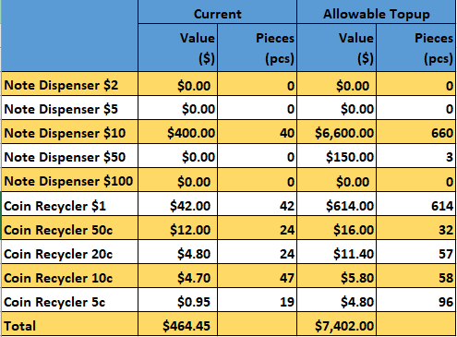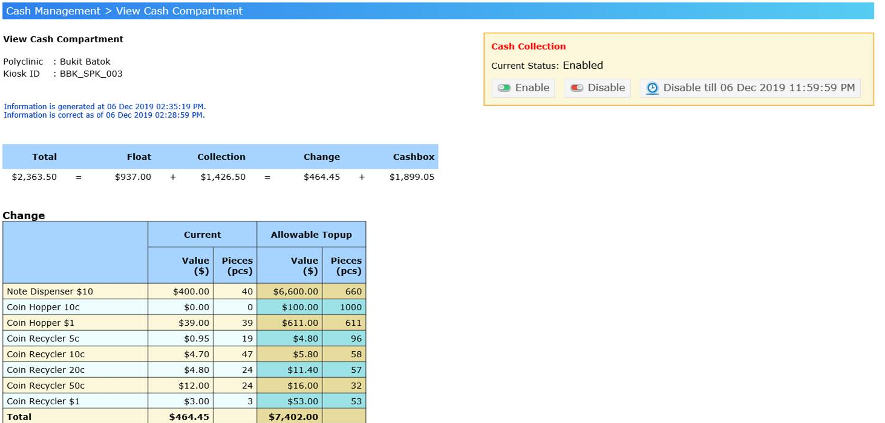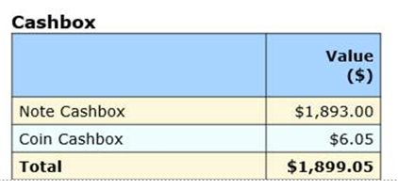

**Input**

| **S/N** | **Field Name** | **Selection Mode** | **Sample Data** | **Default Value** | **Remarks** |
| --- | --- | --- | --- | --- | --- |
| 1 | *Date From* | *Free entry, Calendar Option* | *DD/MM/YYYY* | *Today’s Date* | *-* |
| 2 | *Date End* | *Free entry, Calendar Option* | *DD/MM/YYYY* | *Today’s Date* | *-* |
| *3* | *Polyclinic* | *Dropdown-single selection* | *ALL, Bukit Batok* |  | *-* |
| *4* | *Kiosk ID* | *Dropdown-single selection* | *ALL, BBK_SPK_003* | *ALL* | *List all relevant Kiosk IDs based on the Polyclinic selected.* |

**Output**

| **S/N** | **Field Name** | **Sample Data** | **Remarks** |
| --- | --- | --- | --- |
| 1 | *Input Criteria* | As per input | Based on above input fields (show in exported excel) |
| 2 | *Extracted Date/ Time* | 9/11/2019 11:10:00 AM | Based on report generation date/time (show in exported excel) |
|  |  |  |  |
| 1 | *Timestamp* | 9/11/2019 11:10:00 AM | - |
| 2 | *Polyclinic* | Pioneer | Location |
| 3 | *Kiosk ID* | PIO_KSK_001 | Internal kiosk ID |
| 4 | *Event* | Empty Change,  Empty Cashbox & Collection | Clearance of Float on ad-hoc basis  Collection of Float and Cashbox during end of day |
|  | *Total Cash = Float + Collection = Change + Cashbox before and After Event* | | |
| 5 | *Total Cash* |  |  |
| 6 | *Float* |  | Amount of change filled up in Device during Fill Mode. |
| 7 | *Collection* |  | Amount collected from Device during Empty Mode. |
| 8 | *Change* |  | Total value of cash in in Note Dispensers and Coin Recyclers |
| 9 | *Cashbox* |  | Total value of cash in Note Cashbox and Coin Cashbox. |
|  | Cash In/Cash Out by Compartment | | |
| 10 | *Note Dispenser $2* | $0.00 / 0 | Total Value and number of $2 notes in Dispenser |
| 11 | *Note Dispenser $5* | $0.00 / 0 | Total Value and number of $5 notes in Dispenser |
| 12 | *Note Dispenser $10* | $400.00 / 40 | Total Value and number of $10 notes in Dispenser |
| 13 | *Note Dispenser $50* | $150.00 / 3 | Total Value and number of $50 notes in Dispenser |
| 14 | *Note Dispenser $100* | $0.00 / 0 | Total Value and number of $100 notes in Dispenser |
| 15 | *Coin Recycler 5c* | $0.95 / 19 | Total Value and number of 5c coins in Recycler |
| 16 | *Coin Recycler 10c* | $4.70 / 47 | Total Value and number of 10c coins in Recycler |
| 17 | *Coin Recycler 20c* | $4.80 / 24 | Total Value and number of 20c coins in Recycler |
| 18 | *Coin Recycler 50c* | $12.00 / 24 | Total Value and number of 50c coins in Recycler |
| 19 | *Coin Recycler $1* | $42.00 / 42 | Total Value and number of $1 coins in Recycler |
|  | **Cashbox** | | |
| 20 | *Note Cashbox* | $1,893.00 | Total Value in Note Cashbox |
| 21 | *Coin Cashbox* | $6.05 | Total Value in Coin Cashbox |

*Note: Exportable to Excel*

**Sorting Order**

| **S/N** | **Field Name** | **Remarks** |
| --- | --- | --- |
| 1 | *Note Denomination* | *Smallest Denomination as above* |
| 2 | *Coin Denomination* | *Smallest Denomination as above* |

1. **Appendices**
   1. **Table 18: Output Page of Audit Trail Report (OP-ATR1)**

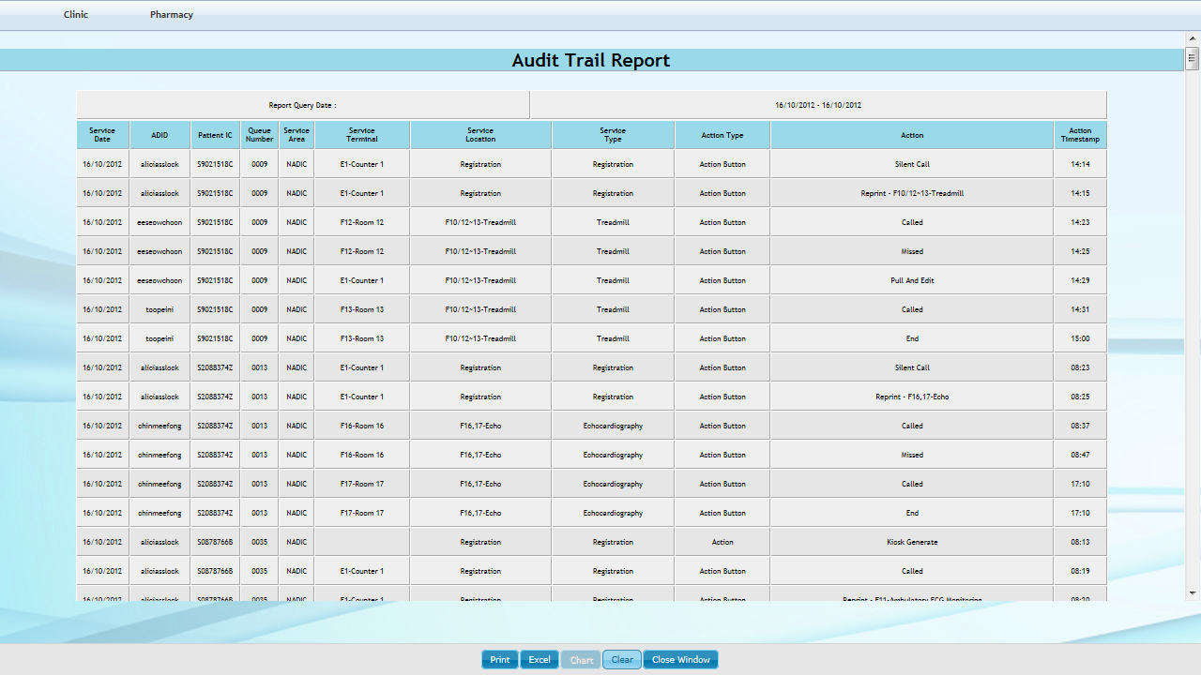

* 1. **Table Relationship**

